srs_notes

5.1

1. In a program that manipulates files and allows massive file copies. SRS-1: “The product should notify regularly the user about its progress”.

1.1 how to notify

1.1.1 It should generate a log on those files (log content and type of log)

1.1.2 It should promote a desktop alter

1.1.3 It should display the copying percentage on the desktop alter

1.1.4 It should check the file content and extension

1.1.5 It should virus scan for files before copying

1.1.6 It should check md5 for copied files

1.2 How often notification

1.2.1 The viewer should initially sit in the task tab

1.2.2 The viewer should hide in the background, user can view the notification by a viewer

**Refined:**

* 1. The product should notify regularly the users about its progress
     1. When files copies start, there should be a copying percentage on the desktop alter sit in the task tab
     2. User should select files first and extension check against those files would be started at the background.
     3. During file copying, process logs should be generated on the local file system. For each successfully copy, there should be always a new line on the log file, increment the background file counter, and percentage on desktop alter move forward based on the percentage calculation between current copied file and total files.
     4. Upon copying process finished, the percentage alter should show the number of files being successfully copied which is derived from the file counter.

2. In an editor of fixed structure documents (like, for example, Microsoft Word): SRS-2: “The program should quickly detect if the structure of the document is incorrect”.

1.1 have pre-defined structure of each format storing in the product

1.1.1 It should check with structures and detect any incorrect part of the document

1.1.2 It should display the outline of those incorrect parts in a dialog

1.2 check the encoding of the file is supported

1.2.1 It should notify user with an alert when encoding is not supported

1.3 detection with no more than 5 seconds

1.3.1 It should file size is up to 100MB

1.3.2 It should raise alert if file size is above 100MB

**Refined:**

* 1. The program should quickly detect if the structure of the document is incorrect
     1. When a document is opened, there should be an outline next to the dialog which is showing the incorrect parts of the document
     2. The detection should be enabled for the document only if the encoding is supported and size up to 100MB
     3. It should use interact with file manipulation interface on the operating system to file extension, use pre-defined encoding stored in the file system to check the document encoding, get the actual file size, raise alter on the dialog if encoding is not supported or file size is above 100MB. Use file extension to traverse the mapping of file type and structure, traverse the file content to check the consistency with the structure.
     4. The incorrect parts should be displayed on the dialog, if not incorrect parts, the dialog should stay empty.

2. What type of errors do you think these specifications help to avoid?

Avoid any inappropriate design may crash the software due to too large file size. Avoid some harmful file being upload that crash the software and platform.

5.2

Read the description of the content to be included in the ‘ands-software-requirements-specification-template-v1-2’ mentioned as a resource.

Section 1.3 should suggest a sequence to read the document for different roles. Write the sequence of sections (or even a subset of the document) that could be useful for the users of the product.

|  |  |  |  |
| --- | --- | --- | --- |
| *1 Introduction*  *1.1 Purpose*  *1.2 Intended Audience*  *1.3 Product Scope*  *1.4 References* | *2 Overall Description*  *2.1 Product Perspective*  *2.2 Product Functions*  *2.3 User Classes and Characteristics*  *2.4 Operating Environment*  *2.5 User Documentation*  *2.6 Assumptions and Dependencies* | *3 External Interface Requirements*  *3.1 User Interfaces*  *3.2 Hardware Interfaces*  *3.3 Software Interfaces* | *4 Functional Requirements* |

Write section 2.4 of the template for your product. Comment with the rest of your team mates the content before the lecture.

|  |  |
| --- | --- |
| *Desktop version:*  Sweet Home 3D should able to run on Windows, Mac OS X 10.4 to 10.10, Linux and Solaris. It should support almost desktop computer hardware platform including INTEL, ARM CPU, supports mainstream graphic Architecture including AMD-ATI, NVIDIA. | *Online version:*  Sweet Home 3D Online should be able to run under Windows (except in Metro mode), Mac OS X 10.4 to 10.10 and Linux,  and requires JavaScript and Java 5 or superior (Java SE 6 update 10 or superior preferred), It should support almost popular browser, such as IE, Chrome, Firefox, Safari and other browser has IE core. |

1. What is the difference between a specific user interface requirement, and a functional requirement?

The user interface refers to how the users interact with the product, whereas the functional requirements refer to how certain functions need to be implemented in the system.

The functional requirements are always with interface requirements. They are not just focused on high level, but also defined different level of functions. They are checked with performance and security rules in the design review.

2. What kind of document could be included in a SRS?

The behavior of the interface, behavior of the interface and the functional requirements.

The behavior of the interface, functional requirements, performance requirements, security requirements, and data flow diagrams, class diagrams, state-transition diagrams.

3. Which of the following properties must be satisfied by the SRS?

Unambiguous; verifiable; complete; consistent; modifiable; traceable

5.3

Scenario: An application to manipulate files in a computer allows the user to select various files and create a ZIP archive. The program allows to create a new archive or update the content of an already existing archive. The user selects a set of files, and a destination name for the archive. If the archive already exists, any deletion or overwriting operation needs to be confirmed. Create an activity diagram that captures this operation.

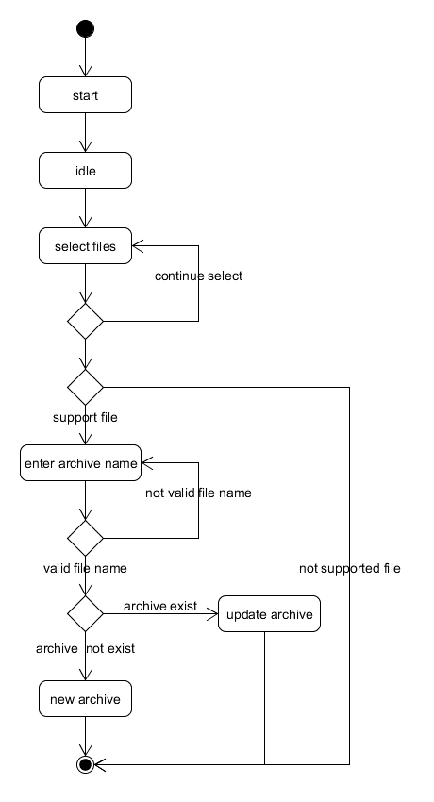

What kind of errors can be avoided with this type of diagrams? *The flow control error can be avoid, such as* not supported file entering into the file compression, incorrect order of steps for selecting files and entering file name.

5.4

Scenario: In a logistics department there is an application supporting both customer requests and stock levels (number of parts still available). A customer places a request, a customer representative processes that order and when ready to be shipped, the customer is contacted to make the payment. If the supply of any of the articles requested by the customer reaches certain level, the representative may choose to place a re-stocking order.

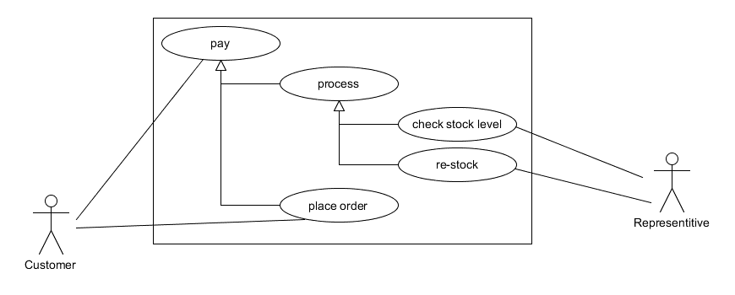

|  |  |  |  |
| --- | --- | --- | --- |
| *Use case:* pay an order | *Risk Level:* low | *Priority:* High | *ID:* 1 |
| Primary Actor​: Customer | | Frequency of Use: High | |
| Goal: customers can request to place an order in the system | | | |
| Scope and Level: System (white-box), level high | | | |
| Stakeholders and interests: customer, representative | | | |
| Trigger: customers just start to place an order | | | |
| Pre-Condition: customers chose some articles | | | |
| Success end Condition: customers pay the order | | | |
| Failed end Condition: customers are not able to pay in the system | | | |
| Normal Flow:   1. An customer place an order 2. An representative checks store level of placed articles 3. Process the order 4. Contact the customer 5. Customer pay the order | | | |
| Alternate Flow/ Sub-variation: not any | | | |
| (Extends/Includes): not any | | | |

What kind of errors can these descriptions help to avoid? Any software design error and missing test cases in test cases design can be spotted by scenario stated by use case.

5.5

1. Regarding actors in a use case. Which one is correct?

There can be an arbitrary number of actors.

There can be more than one actor in a use case description, indicates who to actually initiate the use case.

Some of variations could be initiated by a parent steps.

There is no quantifying relation between actors and stakeholders. Stakeholders are people holding stakes of the system.

2. What is a trigger in a use case?

An event that starts the actions in the use case.

The name of the actor that performs the first action in the case is just the actor triggers the sequence of actions.

The consequence of some event described in the use case is in the normal flow or alternative flow field.

The description of what happens when there is an error is in the failed end condition field.

3. When action A has an arrow labeled “extends” to action B, it means that

Action A is an addition to the functionality described in action B.

Action B is a procedure that does a subset of what is needed by action A should be stated as action A has an arrow labeled “include” to action B.

Action A needs to be extended by action B should be stated as action B has an arrow labeled “extends” to action A*.*

4. When action A has an arrow labeled “include” to action B, it means that

Action B is included in what is contained by action A.

In order to specify order of actions, use arrow to connect each of action with first action on the first place.

Action A is a step within Action B should be stated as action B has an arrow labeled “include” to action A.